**SPRINT 4**

|  |  |
| --- | --- |
| Team ID | PNT2022TMID21469 |
| Project Name | Smart Waste Management System For Metropolitan Cities |

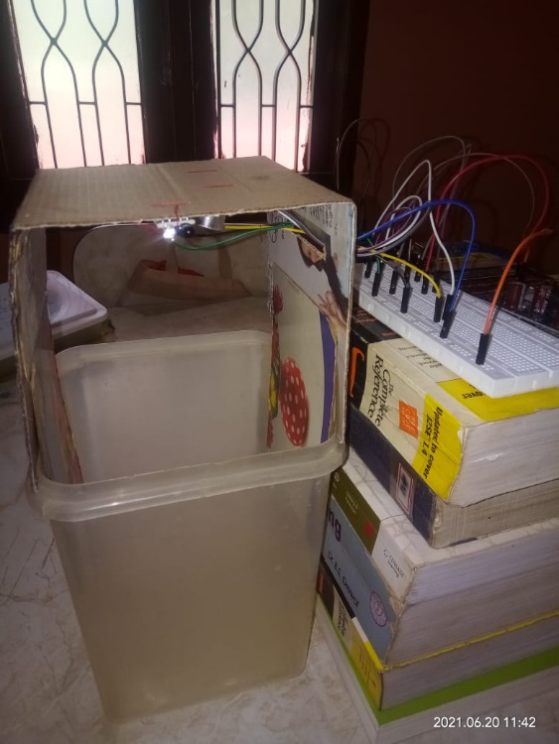

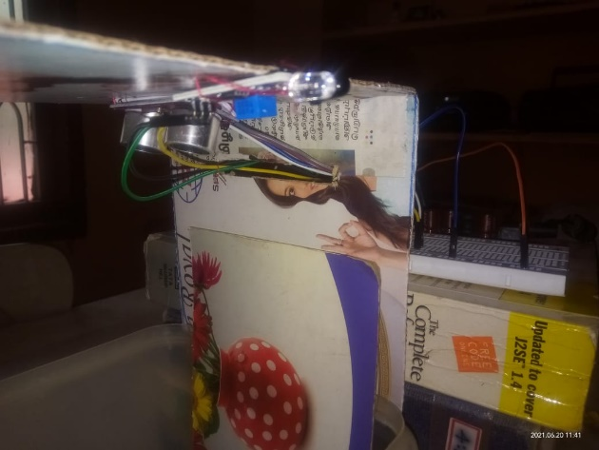

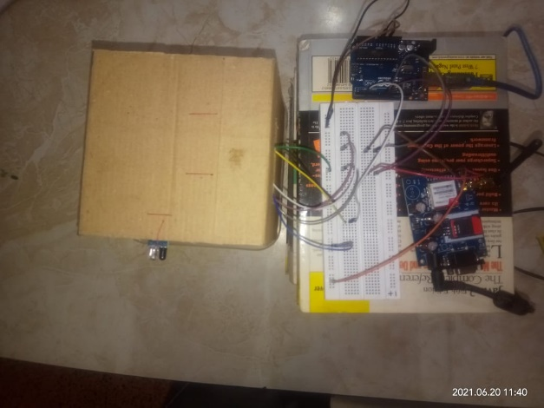

The IoT kit has been assembled and tested.

The Arduino code has been attached.

The details of the sensors are :

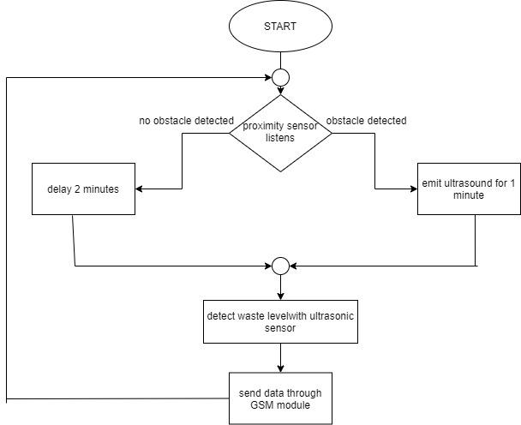

* Arduino UNO - Microcontroller
* GSM Module – Send data to the cloud
* Proximity Sensor – Detect the animals infront of the smartbin
* Ultrasonic sensor – Performs dual functionality to repel the animals and to measure the level
* Weight Sensor (Assumed to produce random values as we don’t have it)